Temasek Polytechnic
School of Informatics and IT

Diploma in Information Technology (IT)

Project Plan

Project Particulars

Tutor | Dr Chia Chaw Poh
Class | P03
Project Title | Delonix Regia Hotel Management System

Project Team’s Particulars

Matric Number | Student Name
1301213C | Wong Sze Siang
1302677H | Kee Yun Mei
1300185D | Gan Kai Xian

Revision History

Date | Version | Description | Author
01/05/15 | 1 | Added Risk Management | Gan Kai Xian
02/05/15 | 2 | Added Product Positioning | Wong Sze Siang
04/05/15 | 3 | Added Objectives and Scopes | Kee Yun Mei
05/05/15 | 4 | Completion of Project Plan | ALL

Table of Contents

Contents
1 Introduction 4
1.1 Objectives and scope of the project 4
1.2 Assumptions and constraints 4
1.3 Definitions and acronyms 5
2 Roles and responsibilities 5
3 Estimates and project schedule 6
3.1 Work breakdown structure 6
3.2 Project Schedule 7
3.3 Budget Summary 7
4 Risk Management Plan 8

Project Plan

1 Introduction

1.1 Objectives and scope of the project

Guest
The online booking of a hotel room would be in a calendar style. Customers will select the dates that they are booking before they would be lead into a page for them to input their essential information. The calendar would be differentiated in three distinct colors which are red for fully booked and green for available rooms. After successful booking of a room, there will be an email sent to notify with a six digit unique code. The code can be used to cancel or make amendments to their booking.

During or after their stay, they would be able to click on the link in the website to go to Delonix Regia social media platform to share their vacation experience. Also, if they were to follow the account, they would also be notified if there were any promotions to be out.

Staff
With a shared database for the hotel, the team leader of each department would then coordinate with each other’s planned scheduled. The employees would also be able to login to check their shift and that would greatly minimize the confusion between the staffs. The special requirements made by the customers would also be showed in the system so that the staffs are able to make arrangement and they would not get mixed up.

The Finance Manager would also be able to create a monthly dashboard with extracted data from the shared database and present it to Mr and Mrs Wang. Staff from the Customer Management would also create a dashboard and upload it onto the website for customers to look through and gain back their trusts.

1.2 Assumptions and constraints

The following are the assumptions made on the project:
- There are 20 rooms available. 5 single rooms, 10 double rooms and 5 family rooms.
- The users have already paid when they confirmed their booking of room.
- Users can cancel their booking online
- Once the user cancels their booking, they will be refunded.
- User will not cancel their booking a day before their arrival
- The website will operate the booking 24/7
- The website is designed for both the client’s staff and customers
- The website has to be clean and simple with easy navigation around the website
- The project finish timeline is subjected to holidays as well
This following are the constraints that may happened during the process of the project. These are not limited to other unexpected constraints such as resources failure or team members falling ill and more.
- Different working time table
- Limited software available
- Software versions are not the same
- Software needs to be purchased after trial use
- Hardware not fast enough to keep up with the software
- Bugs and errors while developing the system
- Different version of work files
- Files are corrupted or has viruses
- Different working speed
- Change of work due date
- Limited hardware resources
- Limited budget
- Limited knowledge of programming language
- Limited knowledge of the software used
- Traffic congestion along the way to work place
- Arriving at work late or leaving work early
- Public holidays halts work on project
- Lack of sleep cause lost in concentration of work
- Property with project information lost along the way to work
- Long meal times
- Feeling sleepy while working on the project
- Unorganized project files

1.3 Definitions and acronyms
There are no definitions and acronyms.

2 Roles and responsibilities

Task | Role
SDLC | ALL
3 Models of development | ALL
TOR – Introduction | Kee Yun Mei
TOR – Objectives of the project | Kee Yun Mei
TOR – Scope of the project | Gan Kai Xian
TOR – Distribution of workload | ALL
TOR - Constraints | Gan Kai Xian
TOR – Resources | Wong Sze Siang
TOR – Product Positioning in Market | Wong Sze Siang
PP – Objectives and scope of the project | Kee Yun Mei
PP – Assumptions and constraints | Gan Kai Xian
PP – Definitions and acronyms | Wong Sze Siang
PP – Roles and responsibilities | ALL
PP – Work Breakdown Structure | ALL
PP – Project Schedule | ALL
PP – Budget Summary | Wong Sze Siang
PP – Risk Management Plan | Gan Kai Xian
Design | ALL
Development | ALL
Implementation | ALL
Testing of features | ALL

3 Estimates and project schedule

3.1 Work breakdown structure
Outline Number | Task Name | Duration
1 | Inception Phase | 10 days
1.1 | Research on hotel businesses | 3 days
1.2 | Completion of Terms of Reference | 3 days
1.3 | Completion of Project Plan | 3 days
2 | Requirement Planning Phase | 5 days
2.1 | Requirements Gathering | 1 day
2.1.1 | Analyze projects objectives and scope | 1 day
2.2 | Revise Terms of Reference | 1 day
2.2 | Revise project plan | 1 day
2.2 | Approval and additional changes | 1 day
3 | Software Design Phase | 6 days
3.1 | Database design | 3 days
3.1.1 | Conceptual database design | 3 days
3.2 | Interface design | 5 days
3.2.1 | Visitor interface | 5 days
3.2.2 | Staff interface | 5 days
3.3.3 | Client interface | 5 days
4 | Construction Phase | 14 days
4.1 | Construction of classes, and their relations | 3 days
4.2 | Creation of backend interface and functionality | 8 days
14.3 | Creation of the frontend interface and functionality | 8 days
4.5 | Integration with database and networking | 7 days
5 | Testing Phase | 6 days
5.1 | Conducting full testing and debugging | 5 days
5.2 | Showcase and review of first build | 1 day
5.3 | Installation of system | 1 day
5.4 | Training of staffs in system usage | 1 day

3.2 Project Schedule
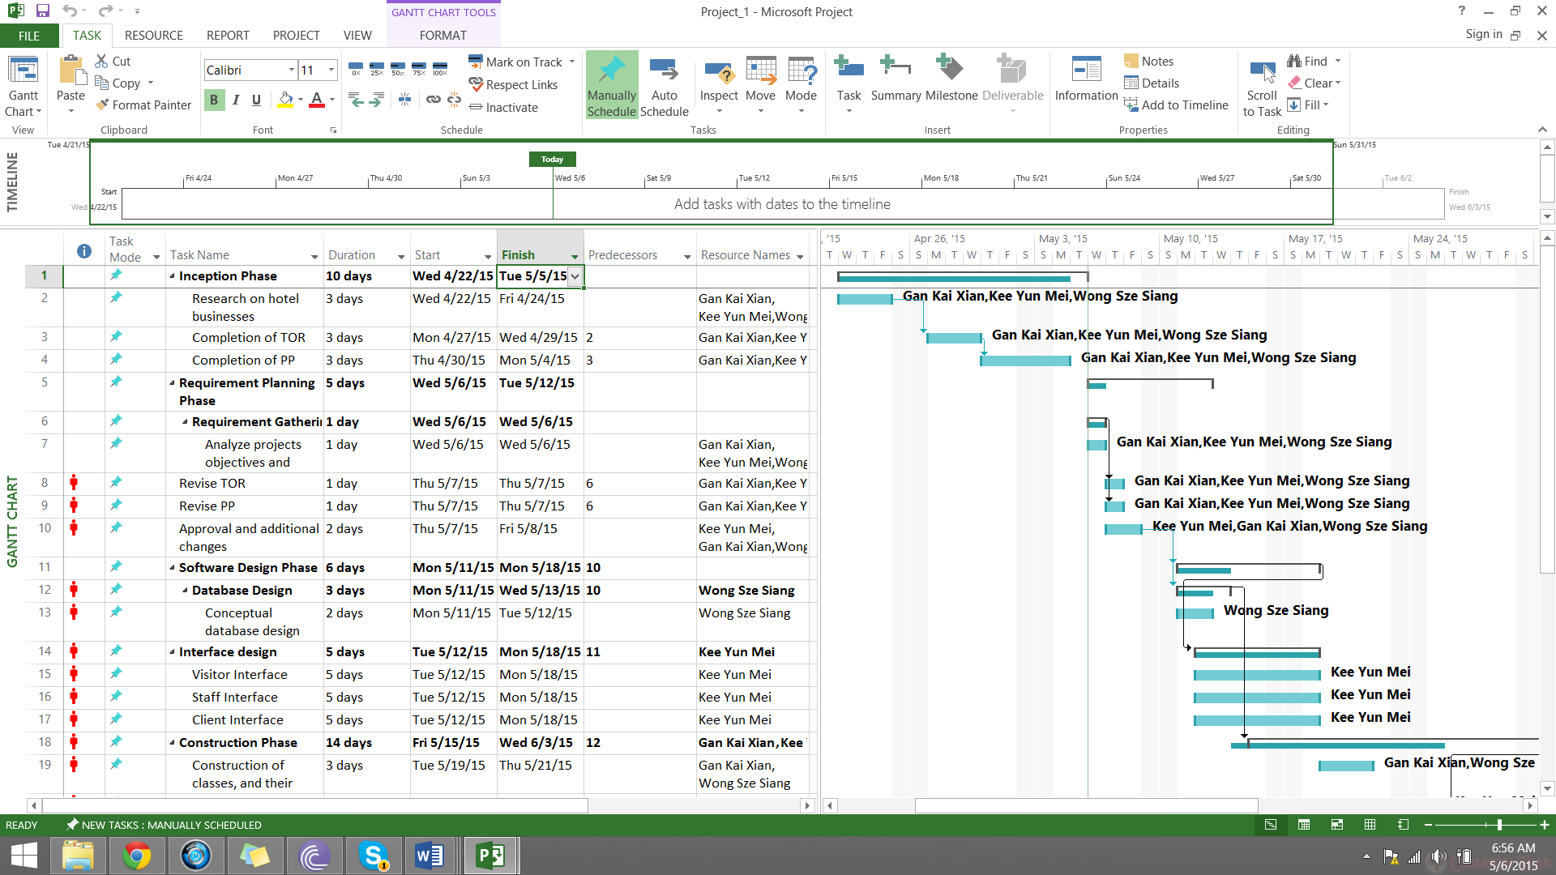

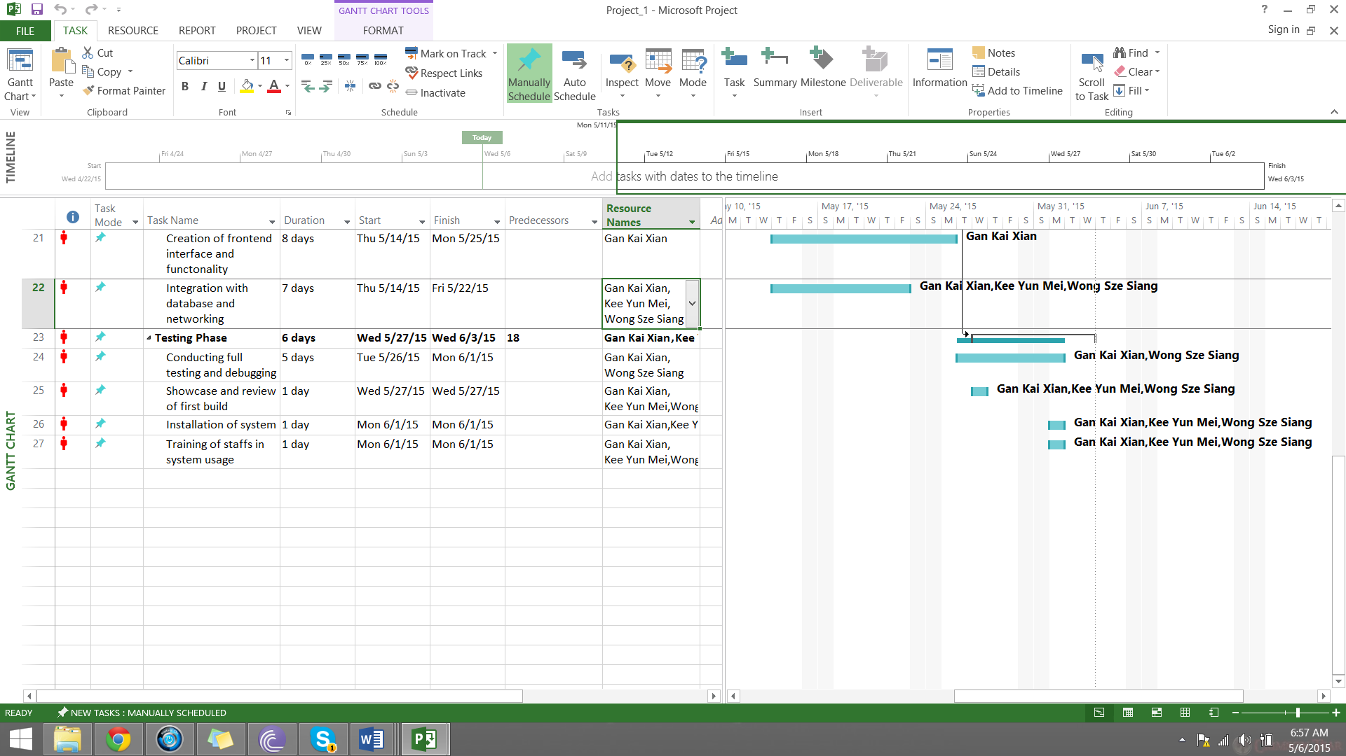

3.3 Budget Summary

 | Net Amount  $ | Sub Amount  $
Resource Expenses  Hardware  Thumb drive  Laptop  Printer | 16 (3)  2000 (3)  200 | 48  6000  200
 |  | 6248
Software  Microsoft Visual Studios  Microsoft Office 2013 Student  Microsoft Project  Go daddy hosting  Adobe Suites  SmartBear TestComplete Platform  Skype | 676 (3)  189 (3)  35 per month (3)  14.99 For 1 year  99 per month (3)  1422.51 (3)  Free | 2028  567  105 (2)  14.99  297 (2)  4267.53  0
 |  | 7681.52
Operational Expenses  General  Travel Expenses  Salary  Office Rental  Electricity  A4 size paper | 200 (3)  1000 per month (3)  Free  200 per month  8 per month | 600  3000 (2)  0  200 (2)  8
 |  | 7008
 | Grand Total: | 20937.52

There are some software that are subscribed monthly because simply purchasing them will have huge cost on the overall project budget, by paying monthly subscription, it is more cost efficient for the client. Some expenses are also listed free such as office rental as we will be working from home and using skype to communicate if we are not meeting at a single location together which is why skype is listed as free too.

4 Risk Management Plan

Risk Category | Type of Risk | Likelihood of Occurrence | Severity of Impact | Risk Exposure
Project | Developer fall ill | High(3) | High(3) | 9
Project | Increase in user requirements during design and development | High(3) | Medium(2) | 6
Project | File corruption | Medium(2) | High(3) | 6
Project | Hardware failure | Medium(2) | High(3) | 6
Project | A task taking longer time than initially planned | High(3) | Medium(2) | 6
Project | Working on different version/date of files | Low(1) | Medium(2) | 2
Project | Increase in duration of whole project | Low(1) | Medium(2) | 2
Project | Software not available | Low(1) | Low(1) | 1
Project | Incompatible/different software version | Low(1) | Low(1) | 1
Technical | Bug/error in developing the user interface | Medium(2) | High(3) | 6
Technical | Bug/error in making a booking for rooms | Medium(2) | High(3) | 6
Technical | Bug/error in showing the available rooms | Medium(2) | High(3) | 6
Technical | Bug/error in database not entering or updating data | Medium(2) | High(3) | 6
Technical | Bug/error in cancelation of booking | Medium(2) | High(3) | 6
Technical | Software used has minimal or no future technology | Medium(2) | High(3) | 6
Technical | Bug/errors calling external API | Medium(2) | High(3) | 6
Technical | Design of user interface is not cohesive | Low(1) | High(3) | 3
Business | Future prove technology not present | High(3) | Medium(2) | 6
Business | Website does not have a niche | Medium(2) | Medium(2) | 4
Business | Not utilizing social media platforms | High(3) | Low(1) | 3
Business | Website not user friendly | Low(1) | High(3) | 3
Business | Minimal knowledge of the nature of business of the user | Low(1) | High(3) | 3

Risk reduction strategies
Risk exposure 1-3
The risks that are minimal or do not pose a considerable amount of concern are not going to be dealt with. These risks are acceptable for us to just live with it and consider dealing with them some other time.
- Risk acceptance
Risk exposure 4-6
These risks are considered to be very concerning and may pose a considerable amount of risk factor along the project which may hinder or halt the project. The risks are to be reduced to the minimum or better to be resolved. Some of these risks may pose a harder chance of reducing them thus we will either negotiate with the requirements or change the scenario to avoid the risk. If the risk does not really halt or hinder the project much, we will consider dealing with it some other time or just let it be.
- Risk acceptance
- Risk avoidance
- Risk mitigation
Risk exposure 7-9
These risks are considered to be a major concern that requires immediate attention and dealt with instantly. The risks are either avoided by changing the scenario or a new plan will be used. Depending of the type of risk, a new plan will be used to carry on the project. Example, when a team member is sick, the other members will take up his/her undone tasks accordingly and return back what has been done so far, once the ill member has recovered. The risk can also be avoided by changing the scenario of the project which may lead to a less serve risk or none at all.
- Risk avoidance
- Risk mitigation
- Risk contingency
Measures taken against risks
Type of Risk | Planned Solution
Developer fall ill | - Divide the remaining tasks among the other members.
Increase in user requirements during design and development | - Adjust to fit in the new user requirements, if major changes are needed, extension of time will be asked from the client to complete the task.
File corruption | - Make backup of files both in the cloud and on the computer
Hardware failure | - Have spare equipment such as mouse or keyboards ready. If computer is down, will use or borrow a spare computer.
A task taking longer time than initially planned | - Find out what is the problem of not completing to task. If needed, extension of time will be asked from the client.
Working on different version/date of files | - Use version control software such as GitHub to sync files and share to all team members.
Increase in duration of whole project | - Find out what is causing the time constraint and if needed, extension of time will be asked from the client.
Software not available | - Depending on what software are not available for which features, we will either live with it or change the features.
Incompatible/different software version | - Make sure software is update to date with the latest version. Use general software that most people will use and is known for compatibility.
Bug/error in developing the user interface | - Find and resolve the bug/error, if it hinders the project severely, the affected feature will be changed accordingly.
Bug/error in making a booking for rooms | - Find and resolve the bug/error, if it hinders the project severely, the affected feature will be changed accordingly.
Bug/error in showing the available rooms | - Find and resolve the bug/error, if it hinders the project severely, the affected feature will be changed accordingly.
Bug/error in database not entering or updating data | - Find and resolve the bug/error, if it hinders the project severely, the affected feature will be changed accordingly.
Bug/error in cancelation of booking | - Find and resolve the bug/error, if it hinders the project severely, the affected feature will be changed accordingly.
Software used has minimal or no future technology | - Change to a different software that provides more future prove features.
Bug/errors calling external API | - Find and resolve the bug/error, if it hinders the project severely, the affected feature will be changed accordingly.
Design of user interface is not cohesive | - Design the user interface during the design phase so that it is cohesive with each other.
Future prove technology not present | - Try adding future technologies, if none are added, client will be informed.
Website does not have a niche | - Gather more detailed user requirements in the initial planning phase.
Not utilizing social media platforms | - Add social media features during development phase
Website not user friendly | - Make the website easy to use with a simple design during the design phase
Minimal knowledge of the nature of business of the user | - Gather more detailed user requirements in the initial planning phase.

The website might not have all the features that are proposed due to deadline given. The key features of the website will be developed first before adding other features if there is time.

